**Catering Industry**

**Stakeholders**

|  |  |
| --- | --- |
| **ACTOR** | **What they can do on the software created** |
| Employee/Customer | ● Place lunch orders  ● Edit orders before checkout  ● Submit feedback |
| Canteen Manager | ● Create and update the daily menu  ● View and process employee orders  ● Request delivery to employees' workstations |
| Delivery Boy | ● Deliver meals to employees' desks  ● Close online customer orders |
| Payroll system | ● Deduct money for dishes ordered from employee's salary  ● Calculate total number of dishes ordered by each employee |
| Management | ● Access reports on popular dishes, system usage, employee satisfaction, sales, monthly earnings, and order forecasting |

**Problem Definition and Solution**

* Existing system inefficiencies result in long wait times for employees.
* Food wastage is a major concern.
* Limited food choices during peak lunch hours.
* Employee dissatisfaction with the current canteen experience.

**Advantages and Objectives**

Advantages of the Canteen Ordering System:

* Improved employee experience.
* Reduced food wastage.
* Cost reduction.

**Objectives:**

* Reduce food wastage by 30% within 6 months.
* Cut operating costs by 15% within 12 months.
* Increase average effective work time by 30 minutes per employee per day within 3 months.
* Automate the ordering process for efficiency.

**Existing System**

* Long wait times during lunch hours.
* Significant food wastage.
* Limited food choices during peak hours.

**Proposed System**

* User friendly interface
* Online menu management.
* Order placement and tracking.
* Feedback submission.
* Reporting and analytics.
* Integration with payroll system.

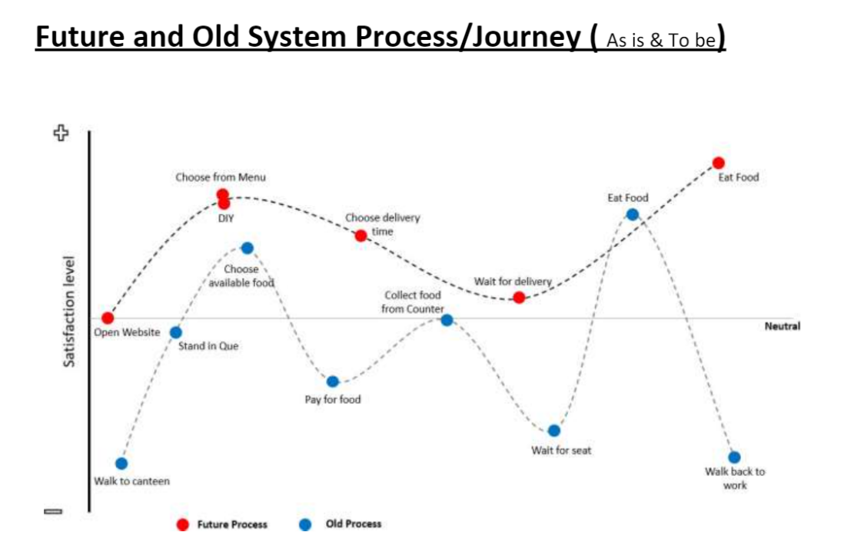

Diagram portraits a vivid picture of how the old process (as is) and Future process (To be) looks like and also depicts how this system change will affect the involving end user. As it shows the old process was tiring with too many contact points and wastage of time which in turn effects the satisfaction level of the involved parties. But the new system completely eliminates all contact points except delivery and takes the wastage of time to a bear minimum which leads to maintain a higher satisfaction level.

**Scope using *context diagram***

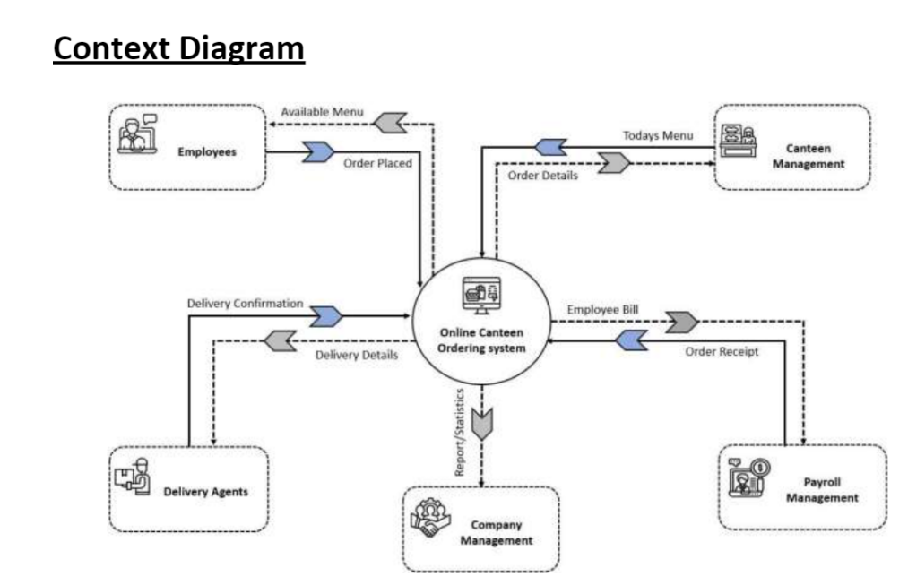

Context diagram gives a bird's eye view on the entire system and the data flows within. It shows how each section acts and how they transform data which they receive as input and give out as output for the next section or process point to carry out.

Online canteen acts as a centre hub for all the data to flow and transform into their respective forms and flow into the next sector. Even when this is a loop, the centre acts as a storage (mostly temporary) the initial trigger comes with the input from the employee side which triggers other entities even when it comes to the report generation at the end of each month (continuous process for continuous improvement and monitoring)

**In Scope**

* Report
* Order Forecasting
* Website
* Worktime
* Order view for Inventory process
* Reduce wastage

**Out of Scope**

* Vendor/Supplier selection
* Free space Utilization

**ER Diagram for the System:**

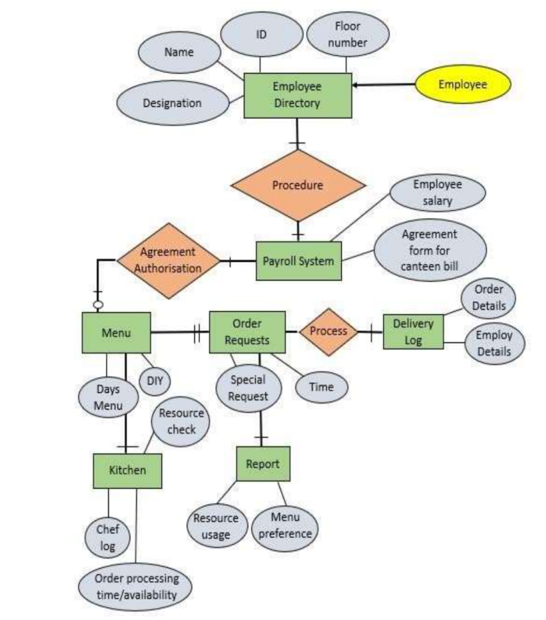

**Business Requirements:**

**Business objective – 1:** Reduce food wastage by 30% within 6 months.

**Business objective – 2:** Cut operating costs by 15% within 12 months.

**Business objective - 3:**  Increase average effective work time by 30 minutes per employee per day within 3 months.

**Business objective - 4:** Automate the ordering process for efficiency.

**Functional Requirements**

* Users can view the daily menu.
* Orders must be placed by 11 am.
* Order editing is allowed before checkout.
* Canteen Manager processes orders.
* Delivery personnel deliver meals.
* Feedback submission is available.
* Integration with payroll system for deductions.
* Reporting functionalities as described.

**Nonfunctional Requirements**

* Scalability to support 1500 employees.
* User-friendly interface.
* Performance: Fast rendering of web pages.

**System Requirement**

**Scalability and Performance:**

* The system should support a volume of 1500 employees ordering.
* Web pages should be lightweight and render quickly.

**Usability:**

* The screens should be self-explanatory and very user-friendly.
* Management aims to ensure that employees understand the screens and data fields on the screen.

**Environments**

* The system will be created and maintained in Java for stability and low maintenance requirements over time.

